**Experiment 3.3**

**Student Name: Md Tabish Faridi UID: 20BCS2191**

**Branch: CSE Section/Group: 20BCS_DM-705B**

**Semester: 6th Date of Performance: 03-05-2023**

**Subject Name: MAD Lab Subject Code: 20CSP-356**

**AIM:** Design the Android application using menus and action bar.

**Steps:**

Following are the steps to create an application using menus and actionbar in android studio.

**Step 1:** Click on New Project and select your required customization with your requirements of your project. Specify your project name, choose your desired language and SDK and specify its path.

**Step 2:** Go on your right panel on your res folder and right click on drawable folder, follow the action sequence as new>>vectorasset

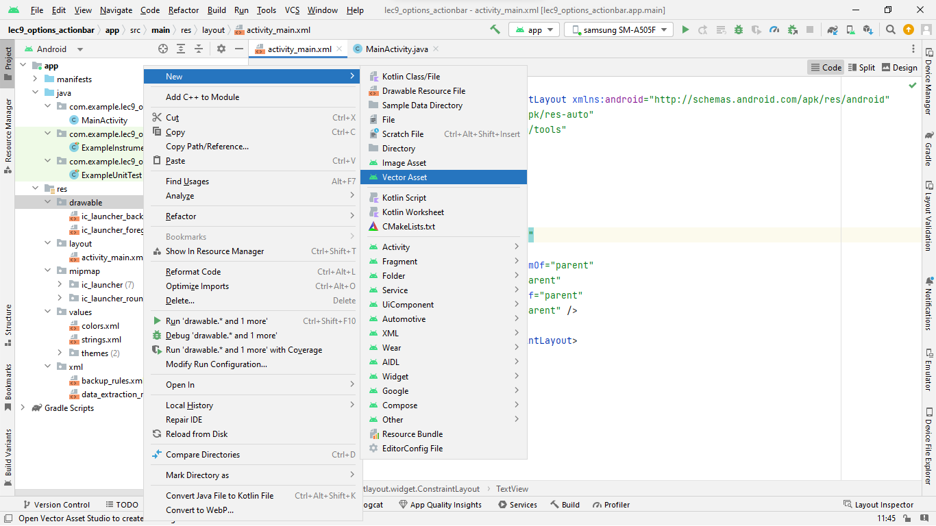

**Step 3:** Set up the variations with your liking.

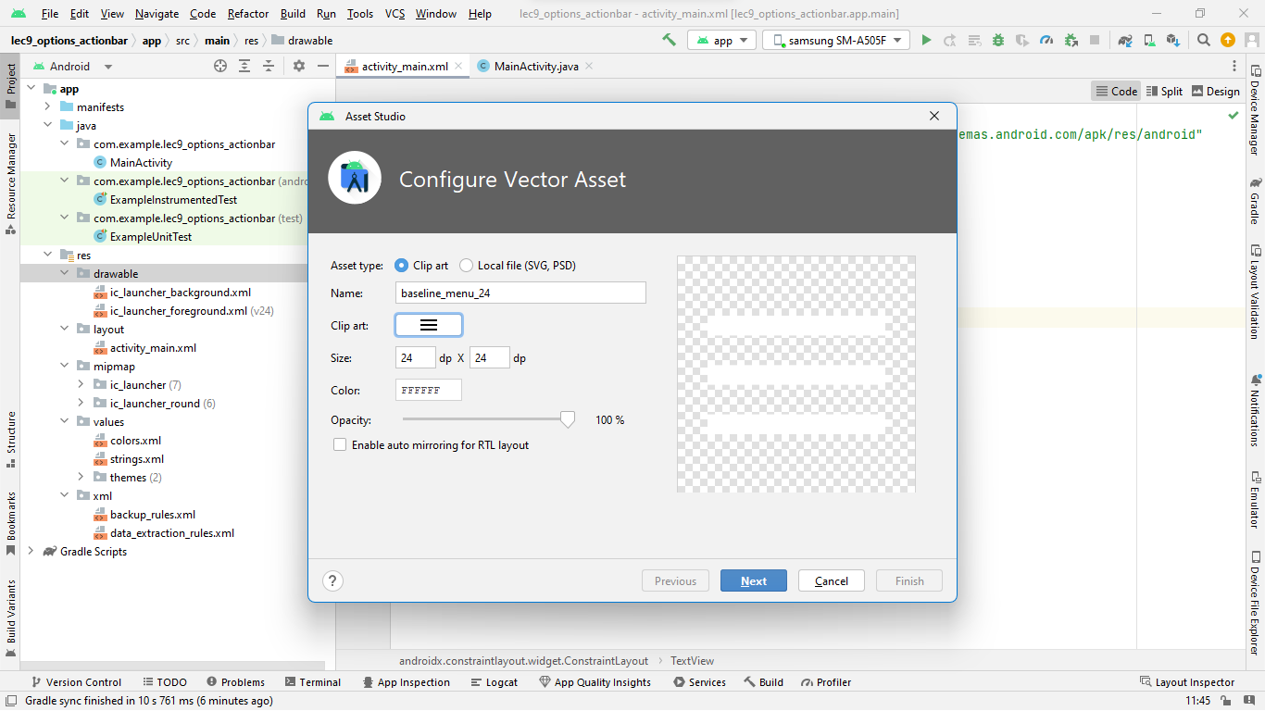

**Step 4:** Now again right click on res folder, and follow the action sequence as res>>new>>android resource directory. A dialog box will show up, fill the resource type there as menu. And click OK. You’ll have a menu folder created in your res folder.

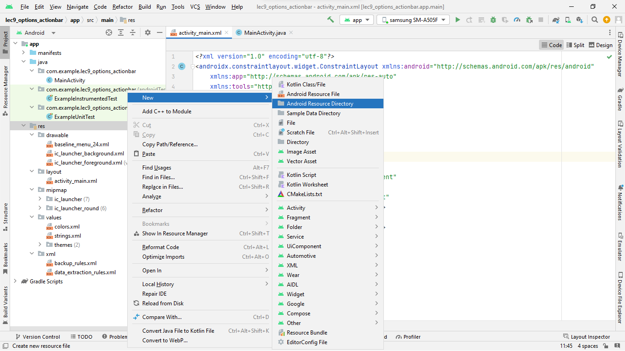

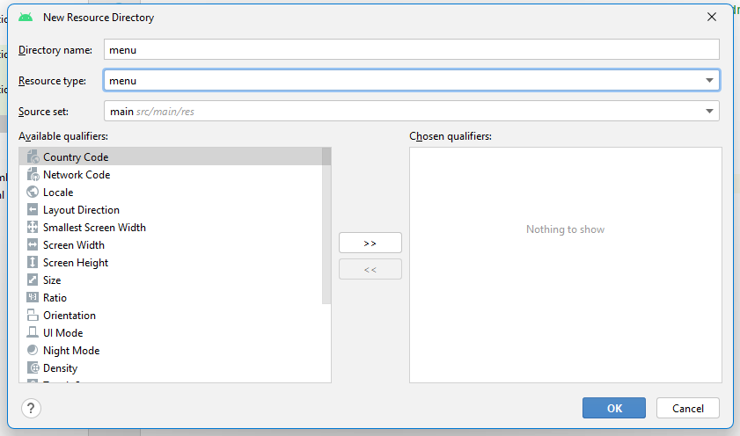

**Step 5:** Now right click on menu folder, and follow the action sequence as new>>menu resource file. A dialog box will show up. Fill up the name as example_menu and click OK.

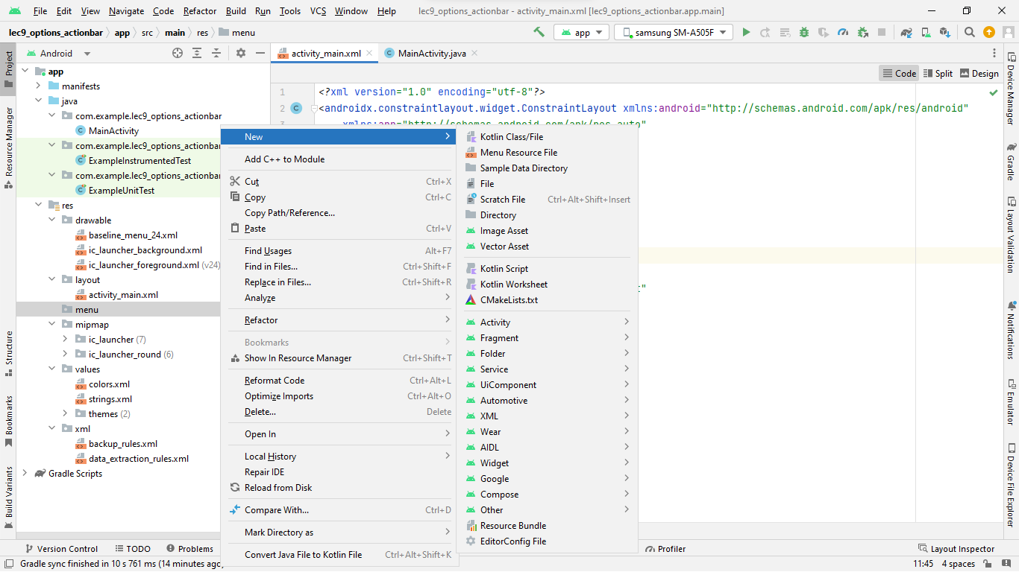

**Step 6:** Program the app and follow up the codes as given below:

Source code of activity_main.xml

*<?*xml version="1.0" encoding="utf-8"*?>*<androidx.constraintlayout.widget.ConstraintLayout xmlns:android="http://schemas.android.com/apk/res/android"  
 xmlns:app="http://schemas.android.com/apk/res-auto"  
 xmlns:tools="http://schemas.android.com/tools"  
 android:layout_width="match_parent"  
 android:layout_height="match_parent"  
 tools:context=".MainActivity">  
  
 <TextView  
 android:layout_width="wrap_content"  
 android:layout_height="wrap_content"  
 android:text="Taabish (20BCS2191)"  
 android:textSize="25sp"  
 app:layout_constraintBottom_toBottomOf="parent"  
 app:layout_constraintEnd_toEndOf="parent"  
 app:layout_constraintStart_toStartOf="parent"  
 app:layout_constraintTop_toTopOf="parent" />  
  
</androidx.constraintlayout.widget.ConstraintLayout>

MainActivity.java

package com.example.lec9_options_actionbar;  
  
import androidx.annotation.NonNull;  
import androidx.appcompat.app.ActionBar;  
import androidx.appcompat.app.AppCompatActivity;  
import android.annotation.SuppressLint;  
import android.os.Bundle;  
import android.view.Menu;  
import android.view.MenuInflater;  
import android.view.MenuItem;  
import android.widget.Toast;  
import java.util.Objects;  
  
public class MainActivity extends AppCompatActivity {  
  
 @Override  
 protected void onCreate(Bundle savedInstanceState) {  
 super.onCreate(savedInstanceState);  
 setContentView(R.layout.*activity_main*);  
  
 ActionBar act = getSupportActionBar();  
 Objects.*requireNonNull*(getSupportActionBar()).setTitle("Menu & Action Bar");  
  
 }  
  
 @Override  
 public boolean onCreateOptionsMenu(Menu menu) {  
 MenuInflater inflater = getMenuInflater();  
 inflater.inflate(R.menu.*example_menu*, menu);  
 return true;  
 }  
  
 @Override  
 public boolean onOptionsItemSelected(@NonNull MenuItem item) {  
 switch (item.getItemId()) {  
 case R.id.*item1*:  
 Toast.*makeText*(this, "Item 1 is selected", Toast.*LENGTH_SHORT*).show();  
 return true;  
 case R.id.*item2*:  
 Toast.*makeText*(this, "Item 2 is selected", Toast.*LENGTH_SHORT*).show();  
 return true;  
 case R.id.*item3*:  
 Toast.*makeText*(this, "Item 3 is selected", Toast.*LENGTH_SHORT*).show();  
 return true;  
 case R.id.*subItem1*:  
 Toast.*makeText*(this, "Sub Item 1 is selected", Toast.*LENGTH_SHORT*).show();  
 return true;  
 case R.id.*subItem2*:  
 Toast.*makeText*(this, "Sub Item 2 is selected", Toast.*LENGTH_SHORT*).show();  
 return true;  
 default:  
 return super.onOptionsItemSelected(item);  
 }  
 }  
}

example_menu.xml

package com.example.lec9_options_actionbar;  
  
import androidx.annotation.NonNull;  
import androidx.appcompat.app.ActionBar;  
import androidx.appcompat.app.AppCompatActivity;  
import android.annotation.SuppressLint;  
import android.os.Bundle;  
import android.view.Menu;  
import android.view.MenuInflater;  
import android.view.MenuItem;  
import android.widget.Toast;  
import java.util.Objects;  
  
public class MainActivity extends AppCompatActivity {  
  
 @Override  
 protected void onCreate(Bundle savedInstanceState) {  
 super.onCreate(savedInstanceState);  
 setContentView(R.layout.*activity_main*);  
  
 ActionBar act = getSupportActionBar();  
 Objects.*requireNonNull*(getSupportActionBar()).setTitle("Menu & Action Bar");  
  
 }  
  
 @Override  
 public boolean onCreateOptionsMenu(Menu menu) {  
 MenuInflater inflater = getMenuInflater();  
 inflater.inflate(R.menu.*example_menu*, menu);  
 return true;  
 }  
  
 @Override  
 public boolean onOptionsItemSelected(@NonNull MenuItem item) {  
 switch (item.getItemId()) {  
 case R.id.*item1*:  
 Toast.*makeText*(this, "Item 1 is selected", Toast.*LENGTH_SHORT*).show();  
 return true;  
 case R.id.*item2*:  
 Toast.*makeText*(this, "Item 2 is selected", Toast.*LENGTH_SHORT*).show();  
 return true;  
 case R.id.*item3*:  
 Toast.*makeText*(this, "Item 3 is selected", Toast.*LENGTH_SHORT*).show();  
 return true;  
 case R.id.*subItem1*:  
 Toast.*makeText*(this, "Sub Item 1 is selected", Toast.*LENGTH_SHORT*).show();  
 return true;  
 case R.id.*subItem2*:  
 Toast.*makeText*(this, "Sub Item 2 is selected", Toast.*LENGTH_SHORT*).show();  
 return true;  
 default:  
 return super.onOptionsItemSelected(item);  
 }  
 }  
}

**Step 7:** Connect your physical device or launch up your AVD and run your app on your device.

**App Output:**

